
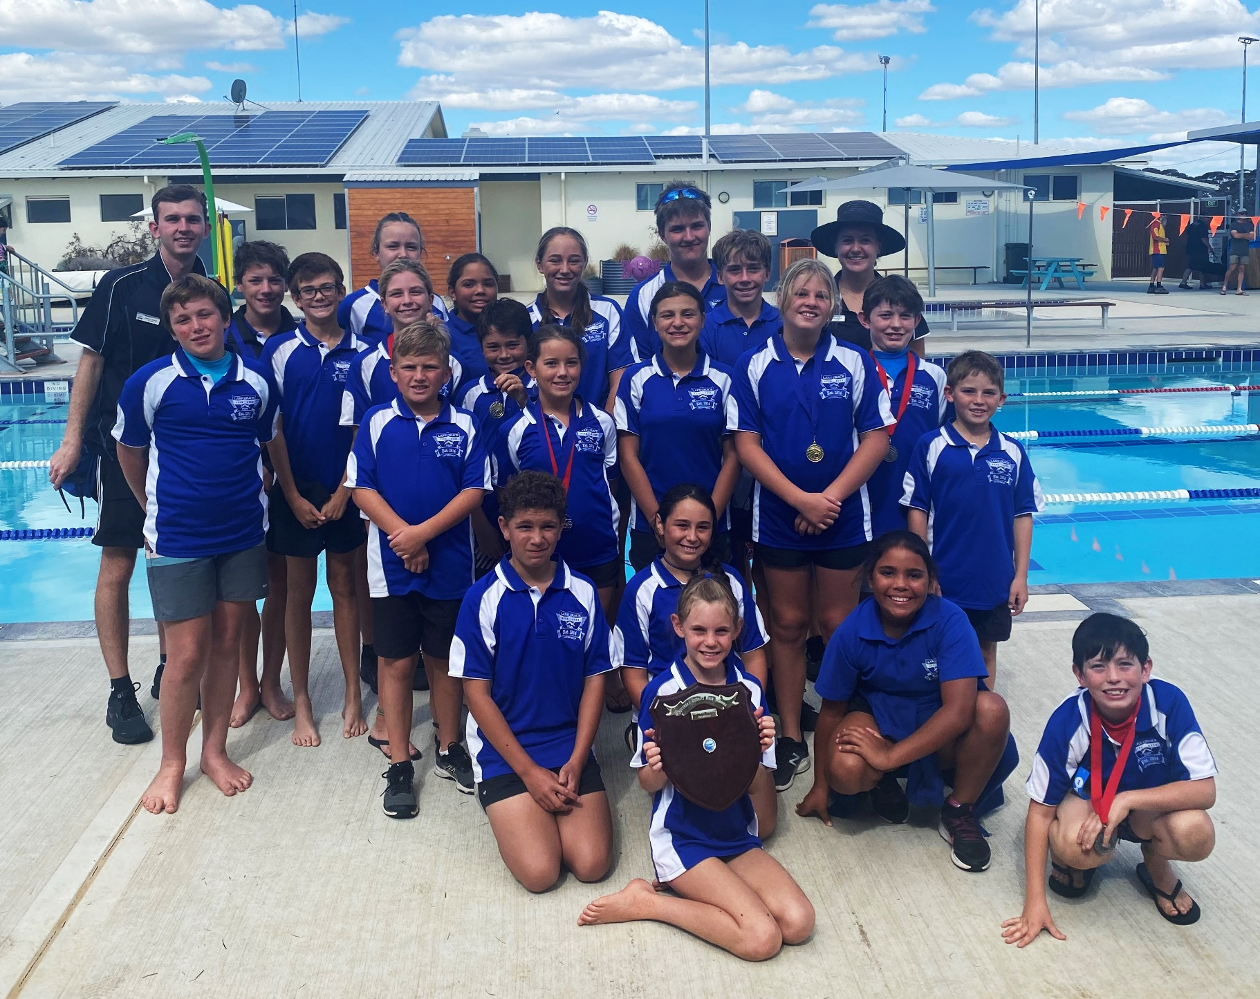
Parent Information Handbook 2021

“As partners in education, we can together support your
greatest investment - your children.”
Scott Tapper, Principal
Contents

Contents
Contact Details 3
Term Dates 2021 3
Hours of Instruction 3
Welcome 4
Our Vision 5
Our Pledge to Community 5
Our Values 5
The School Board 6
Our P&C Association 6
Services 6
School Bus Services 6
Lockers 6
Canteen 7
Contributions and Charges 7
Communications 7
Please Notify Us If... 7
Medical Conditions 8
Assemblies 8
Newsletters 8
Reporting 8
Absentees 8
Bus Students 8
Visitors to the School 8
Attendance 8
Dress Code for Students (Kindergarten – Year 12) 9
Personal Technologies 11
Personal Property 11
Curriculum 11
Student Health and Well-Being 13
Bullying 13
SDERA 14
Chaplain 14
School Nurse 14
School Psychologist 14
Allergies and Anaphylaxis 14
Administration of Medication 14
Dental Health Service 15
Infectious Diseases 15
Head Lice 15
Emergency Procedures 17
School Creed 17

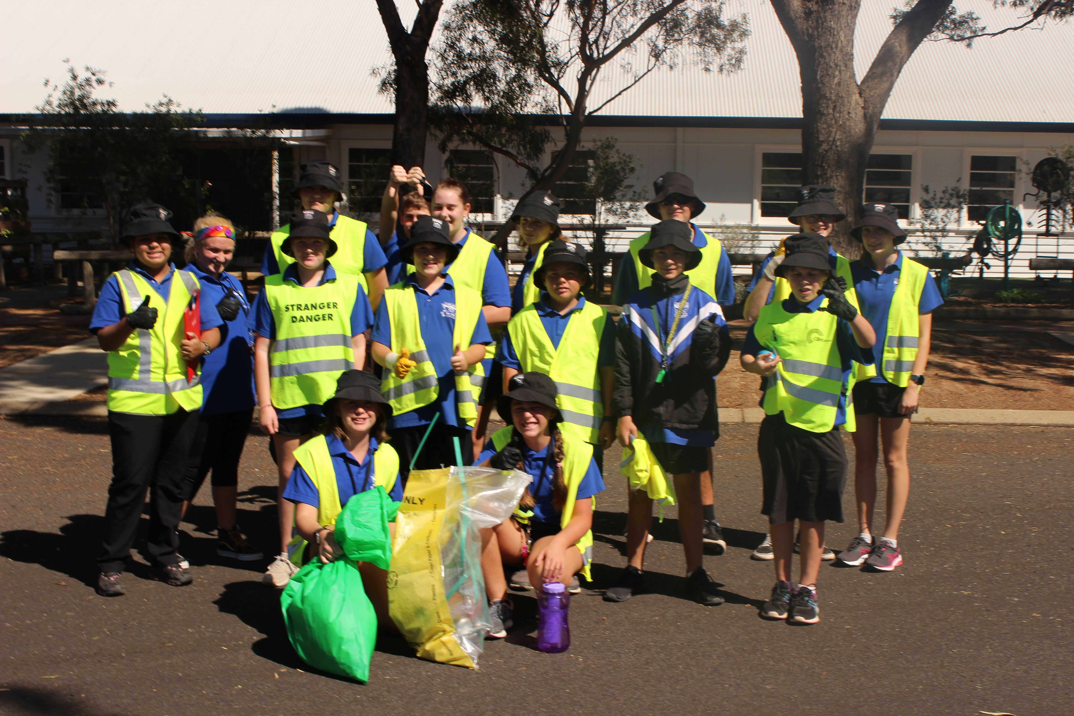
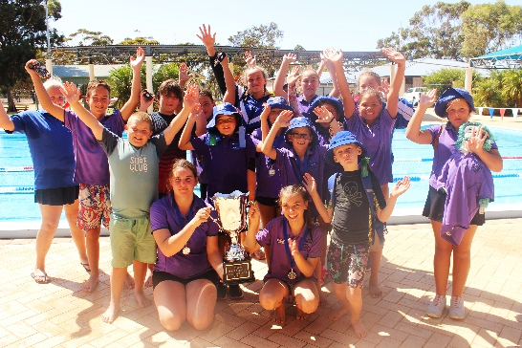
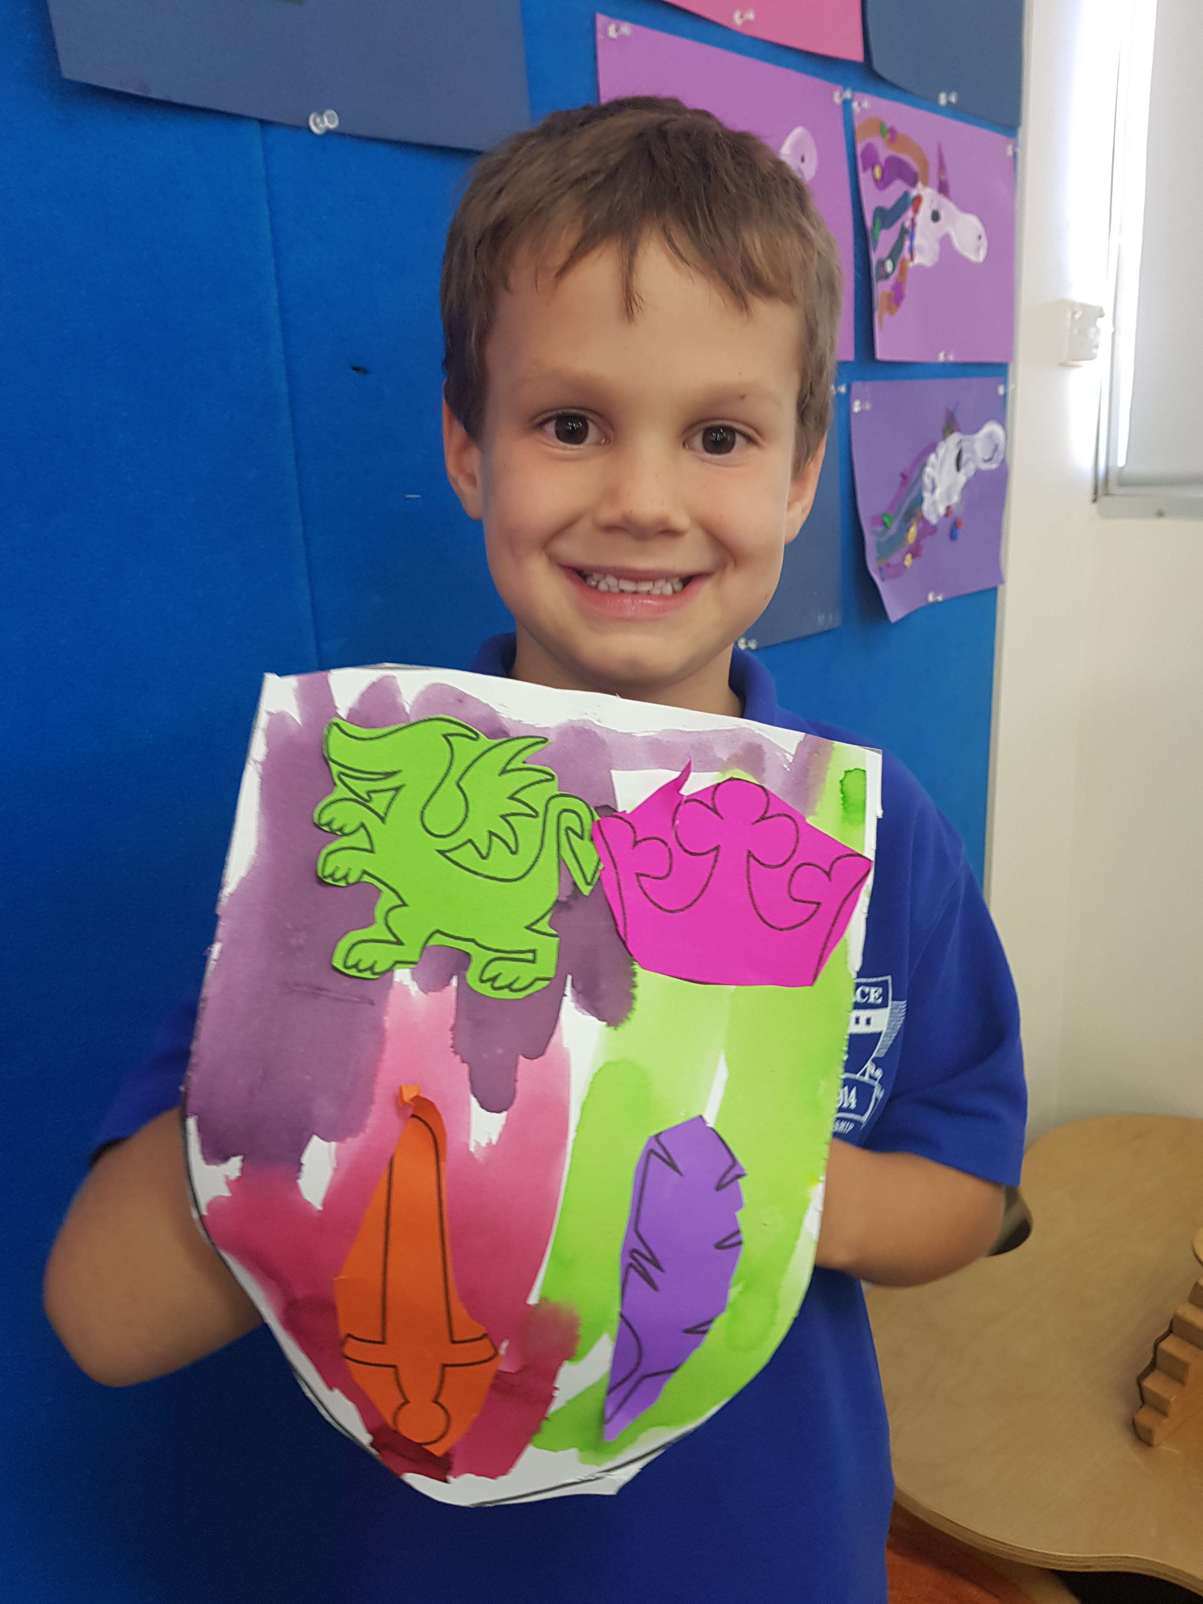

Contact Details
Lake Grace District High School
Phone: 9865 4500
Email: lakegrace.dhs@education.wa.edu.au

1 School Place
Lake Grace WA 6353

Principal: Mr Scott Tapper
Deputy Principal: Mr Peter Dines
Manager Corporate Services: Mrs Michelle Lay

Term Dates 2021

Semester 1
Term 1 | Monday 1st February – Thursday 1st April
Break | Friday 2nd April – Sunday 18th April
Term 2 | Monday 19th April – Friday 2nd July
Break | Saturday 3rd July – Sunday 18th July
Semester 2
Term 3 | Monday 19th July – Friday 24th September
Break | Saturday 25th September – Sunday 10th October
Term 4 | Monday 11th October – Thursday 16th December

There are six (6) School Development Days where students do not attend:
Term 1 | Term 2 | Term 3 | Term 4
Thursday 29th January  Friday 30th January  Tuesday 2nd March | Tuesday 27th April | Wednesday 1st September | Friday 17th December

Hours of Instruction
Monday |  | Tuesday - Friday
Period | Time | Period | Time
1 | 8.45am – 9.40am | 1 | 8.45am – 9.40am
2 | 9.40am – 10.35am | 2 | 9.40am – 10.35am
Recess 10.35am – 10.55am
3 | 10.55am – 11.50am | 3 | 10.55am – 11.50am
4 | 11.50am – 12.45pm | 4 | 11.50am – 12.45pm
Lunch 12.45pm – 1.25pm
5 | 1.25pm – 2.30pm | 5 | 1.25pm – 2.20pm
Early Close  (staff planning & staff meetings) |  | 6 | 2.20pm – 3.15pm
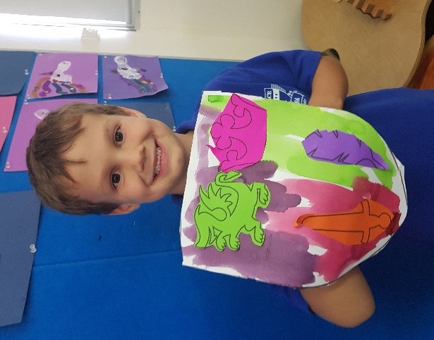
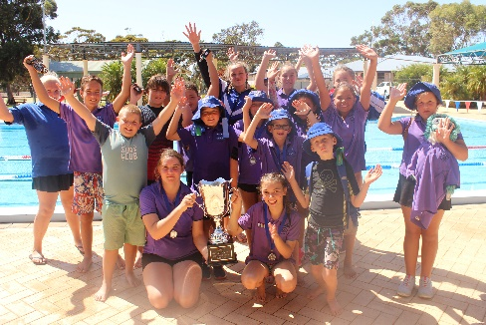
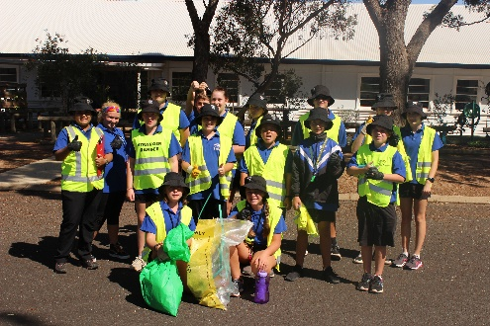

Welcome
Principal’s Foreword | Mr Scott Tapper

Dear Parents, Families and Visitors,

I would like to extend a warm welcome to you and your family to the Lake Grace District High School. Lake Grace DHS has a proud tradition of being inclusive, supportive and providing students with a high quality education for students in Kindergarten to Year 12. Behaviour is exemplary, our culture is positive and academic standards and expectations are high. Students benefit from low class sizes with a strong focus on supporting the social-emotional development of every child. Lake Grace is a vibrant, energetic and optimistic place to be, striving to be inspirational and aspirational every day.
Parent and community involvement in our school is greatly valued, and forms the foundation of our commitment to providing a school which is reflective to the needs of its students, staff, families and wider community.
We regard you, the parents/carers, as your child’s first and most important teacher. From you they learn things that will be vital to their success in school. They learn to be inquisitive about their world; to be interested in books, shapes, colours and numbers. Your children also learn patterns of behaviour that will determine how they react to the many situations that occur in school life, to shape them as responsible and active citizens.
When your children start their journey at LGDHS, their education becomes a partnership between our school and you. By working harmoniously, we hope to build on the foundations you have provided to enable your children to achieve their potential.

I look forward to working with you and your family for the years to come.
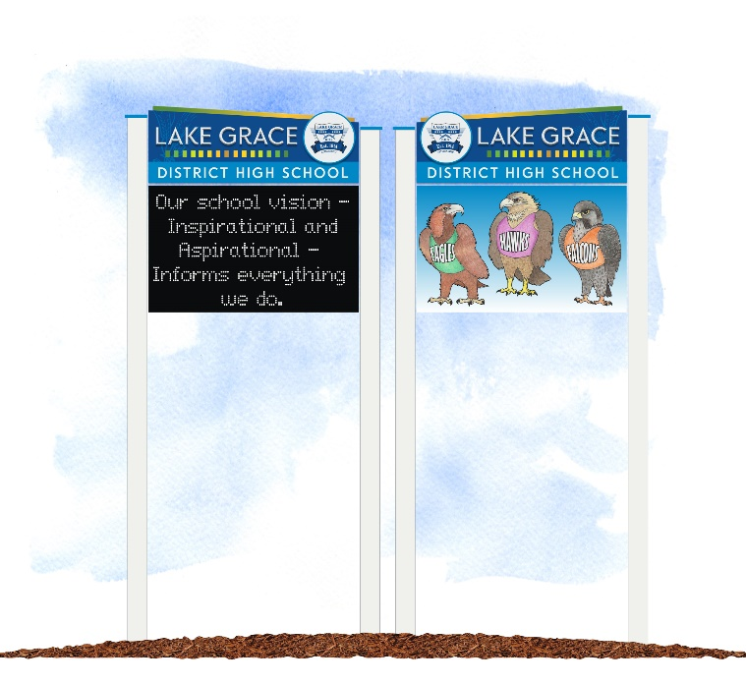
Best wishes,

Scott Tapper
Principal
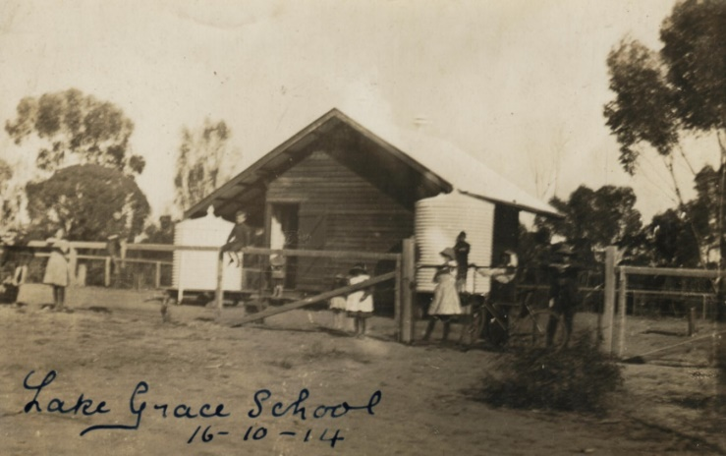

Our Vision
To support and guide our students to succeed through high quality teaching and enriched community partnerships.

Our Pledge to Community
- We listen to our students, staff and community to reflect their changing needs.
- We are proactive to change, embracing innovation and leadership in all that we do.
- We embrace and celebrate excellence.

Our Values
At Lake Grace District High School our beliefs and values guide our actions.



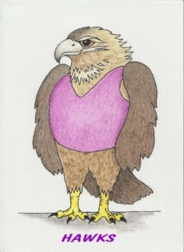
Our school is represented by the factions of: Hawks, Eagles and Falcons.

The School Board
The School Board plays an integral role in setting the direction for the school, providing an opportunity for parents, community members and school staff to work together in the development of the school and its objectives. The School Board primarily assists with the implementation and monitoring of the school Business Plan, whilst also reviewing and noting key policies, plans and documents used to support the ongoing improvement of the school.

By including all parties in the decision making process, broad consensus can be achieved and policies put in place to best address the needs of Lake Grace DHS students.

Our P&C Association
The Parents & Citizens Association (P&C) is a dedicated group of people committed to involving the whole school community in the continual advancement in the quality of the students’ education.

The P&C Association is open to all parents of children at school, to staff and any interested citizens. They aim to support the day-to-day activities of the school as well as being heavily involved in fundraising for major school requirements.

Meetings are usually held twice per term on the third Monday of the month. Dates and times are advised through the school newsletter.

The AGM is usually held within the first month of the start of the school year. Everyone is welcome.

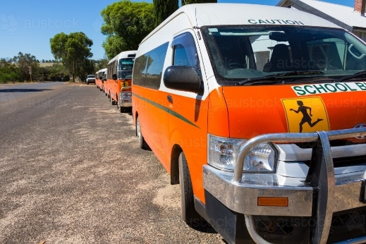
Services

School Bus Services
Four buses service our school: North, South, Tarin Rock and Pingaring. School Bus Services are responsible for the modification of bus routes.

A nominated representative of each bus route can request a meeting for parents of children travelling on that route to discuss issues directly relating to safety and behaviour on the bus.
Application for the use of an existing school bus route is made via the School Bus Services website: www.schoolbuses.wa.gov.au.

Teachers and bus drivers should be notified of any changes to normal routine. Please contact your bus driver if your child will not be travelling. If your child wishes a friend to travel on the bus, a pass must be obtained from the front office, completed and returned prior to the date/s of travel.

A high standard of behaviour is expected of all students whilst travelling on buses and while waiting for the bus. Any concerns about student behaviour should be reported to your school bus contractor.

Lockers
Lockers are issued at the beginning of the year to each secondary student. Students are to provide a $5 deposit for the key, which is returned at the end of the school year. If the key is lost, students will be charged $5 for a replacement key.

Canteen
The school canteen is operated by the P&C. It is run by parent volunteers and operates every Monday. In the case of long weekends and School Development Days, the canteen will operate on Tuesday.
Volunteers are always appreciated at the canteen. Please contact our P&C to find out how you can assist.


Contributions and Charges
Voluntary Contributions
To assist with the running of programs in the school and to supplement the grant provided by the Department of Education, parents are asked to support the school by paying a voluntary contribution of $60.00 per Primary student (K-6) and $235.00 per Secondary student (7-10). Contribution amounts are set and ratified by the School Board each year.

Contributions collected at LGDHS are used to purchase reading and library resources, curriculum resources, ICT, and a variety of services and facilities which support our programs.

Voluntary contributions are payable at the front office or via direct debit. A payment plan may be organised with our Manager Corporate Services, Mrs Michelle Lay. Although these contributions are voluntary, they are greatly valued by the school and we appreciate payment at the beginning of the year where possible.

Charges
Charges refer to the anticipated cost of extra activities throughout the school year such as school camps, excursions, incursions or swimming lessons. Participation in activities that incur a charge is optional. Parents are required to pay for the activity before the deadline or enter into a payment plan in order for their child to participate. These activities are incorporated into the school’s educational program and it is highly recommended students participate.

Each year the school provides a list of approximate costs parents may expect to pay in additional charges for the following year.

Communications

Please Notify Us If...
- Your child is ill - keep him/her home and notify the school.
- Your child has an infectious illness, or any medical condition or allergy we may need to know about.
- You wish for anyone other than yourself to collect your child. If this is to be a regular arrangement, please inform us so that we can record it in our student information system.
- You change your address or telephone number throughout the year. This is very important, especially in emergency situations. The school contact number is 9865 4500.
- There is any change in your child’s normal routine, health etc. Often things such as a parent in hospital, death in the family, or grandparents visiting can affect children’s behaviour.

Medical Conditions
Please notify the front office if your child has any medical conditions and/or allergies.

Assemblies
Assemblies are held twice per term - generally in Weeks 4 and 8, at 2:20pm in the Undercover Area.


Newsletters
The school newsletter is sent home every fortnight via email, Schoolstream and a paper copy via your child. It can also be found on the school website. Please ensure the office has your current email address on file.

Reporting
Parents are provided with a formal report at the end of Semesters 1 and 2 with Open Afternoons/Evenings held in Terms 1 and 3. These are a great opportunity to see your child’s work and chat to staff. Interviews may also be requested by staff throughout the year. As a parent, you are welcome to ask for an interview at any time, should you wish to discuss your child’s progress and any concerns you may have.

Absentees
Please notify the school if your child is absent from school, for any reason. This may be done in writing, via Schoolstream or by phoning the school. We also have a SMS service which will send you a message when your child is absent. You may reply to this message as your notification.

Bus Students
All bus students will be sent home on the bus unless the school is notified by a parent.



Visitors to the School
Please sign in at the front office when visiting the school. This includes times when you are a parent helper or volunteering at canteen.

Attendance
Regular attendance is vital to student progress. It is essential that students attend school every day. Statistics show that attendance below 90% places a child AT RISK of not achieving their educational potential.

- 90-100% Attendance is regarded as REGULAR
- 80-89% Attendance is regarded as at RISK
- 60-79% Attendance is regarded as at HIGH RISK
- 0-59% Attendance is regarded as at SEVERE RISK

Absences
On returning to school, every child must bring an explanatory note from a parent/guardian providing an acceptable reason for the absence. If an absence is known in advance, parents are asked to advise their child’s teacher. Verbal communication is also acceptable. Parents/carers are recommended to complete an absence notification via Schoolstream.
Leaving School Grounds
Students who need to leave the school grounds for any reason must have verbal notification or a note from their parent or guardian. Students will need to sign out from the office. If leaving the grounds without a parent, students will need to obtain a leave pass.

Punctuality
It is essential that students arrive to school on time each day to maintain routines and engage positively with the teaching and learning programs. The school day commences at 8.45am.

Dress Code for Students (Kindergarten – Year 12)
Rationale
The school’s dress code is important in promoting a positive image of the school and in creating a sense of identity. There are also positive safety aspects in being able to readily identify students both at school and on excursions.

The School Board has a responsibility in determining what is appropriate for the school’s circumstances. School management of the dress code is a delicate balance between establishing school standards, allowing reasonable opportunity for student self-expression, and taking into account diverse cultural backgrounds. The school dress code therefore reflects the unique circumstances of our school community.

Holders of pension and health care cards are eligible for clothing assistance - this generally applies for students between 13-16 years of age. Details of the assistance scheme are available from the school office.

All new students enrolling at LGDHS will be supplied with a complimentary school hat.

Standards
For the health and well-being of all students it is necessary that all students are clean and well-groomed including clipped fingernails and long hair tied back.

Permitted Exceptions | Not Permitted  (unless listed in permitted exceptions list)
- Studs or sleepers for pierced ears or noses  - Watches  - Cultural/religious/medical jewellery with Principal consent | - Jewellery  - Body piercings  - Cosmetics (make up)  - Nail polish and extensions

Students must wear the school hat. The school has a policy of “No Hat – No Play” which applies in Terms 1 and 4, as LGDHS is a SunSmart endorsed school.

School Uniform - Primary & Secondary (K-12)
- School polo shirt.
- Faction polo shirt.
- Skirt, black.
- Shorts, black. Plain shorts only - no logos or stripes.
- No leggings or bike pants without skirts or shorts (of modest length) worn over the top.
- Track suit pants, black. Plain pants only.
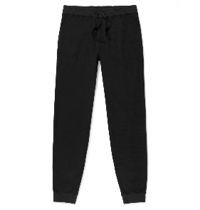
- School polar fleece jacket.
- School windproof jacket.

Faction shirts can be worn on Team Tuesday and Faction Friday.

Footwear
- Footwear must be worn at all times.
- Footwear should be well-fitting and firmly secured to the foot. Thongs, step-in shoes, boots and platform shoes are deemed inappropriate.
- Closed-in shoes must be worn in Home Economics and Design & Technology.
- Sports shoes are required in Physical Education.

All clothing items can be ordered through the uniform shop. All clothing must be marked with your child’s name. The school will not accept responsibility for losses.

Cadets
Secondary students participating in Cadets (Years 7-9) will be provided with a full Cadet uniform to be worn on ceremonial occasions and other times outlined by the Cadet Leader.

Compliance with the Dress Code
A student may be unable to participate in a school activity when the activity would constitute, or would be likely to constitute, a hazard to the student, other students or school staff as a result of:
- Clothing worn by the student, including headwear or footwear;
- Jewellery in the form of earrings, bangles or rings in identified high risk settings and/or activities, or facial piercing;
- Long hair not tied back;
- Footwear worn in a particular activity or high-risk setting.
A parent may apply to the Principal (on behalf of their child) for an exemption from aspects of the dress code on any of the following grounds:
- A matter relating to the child's health;
- A matter relating to religious beliefs of the child or their family;
- A matter relating to the cultural background of the child or their family; and,
- Any other matter which, in the Principal’s opinion, is sufficient to exempt the child from complying with the requirements.
Exemptions may be granted on a permanent, defined-period or conditional basis and can be revoked by the Principal at any time.

Where a child is not following the school dress code (unless they have an exemption):
- The matter will be discussed with their parent/carer;
- The child will be encouraged to meet the requirements of the dress code (in a positive way);
- Assistance will be provided (as applicable) to assist the child to meet any specific requirements and;
- The child will not be able to publicly represent the school or go on an excursion (unless it is part of the essential educational program of the school).

Personal Technologies
The use of mobile phones, iPads/tablets etc, is not permitted at school. If students have these items at school they must keep them securely stored away during the day. Alternatively, they may be brought to the office for safe-keeping.

Students who are found using personal technologies
during the day will have these confiscated for the
remainder of the day. They will need to collect these
items from the office at the end of the day.

Repeated offences will result in consultation with parents about further consequences.

Personal Property
Students are strongly encouraged not to bring personal items/valuables to school, such as toys, electronics and jewellery.
No responsibility is accepted by the school for the loss and/or damage to personal items.

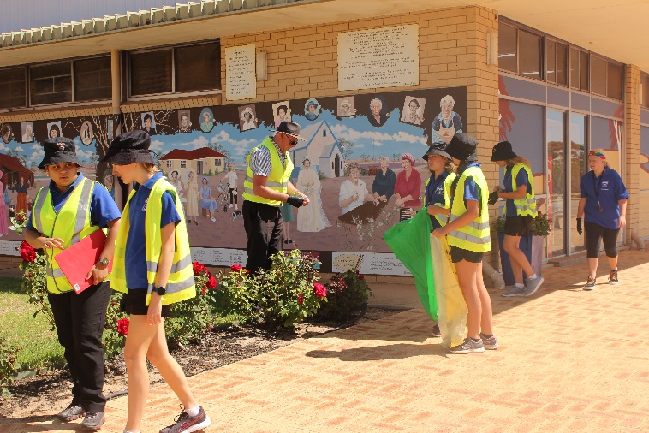
Curriculum
Lake Grace DHS provides a quality, robust curriculum for all students (the Western Australian Curriculum). This sets out guiding principles for teaching, learning and assessment, and support for teachers in their assessment and reporting of student achievement from Kindergarten to Year 10. The expected standard for student achievement is consistent across the state.

Our school has many great facilities, including a purpose built Arts and Music room, Science laboratory, Home Economics room and Manual Arts room. We have sets of student laptops and ipads in each room to enable a high level of ICT use for students.

Students benefit from receiving two hours of Physical Education per week from a specialist Sports Teacher. As a part of the Physical Education program, all students from Pre-Primary to Year 6 are involved in a two-week intensive swimming program in Term 1.

Students in Years 7-9 participate in the Cadets WA Program (Emergency Services Cadets Corps). This provides an interesting and challenging program which provides practical life skills, develops leadership, teamwork and initiative, and fosters the qualities of community responsibility and service.

Homework
Homework is directly related to the teaching and learning program from the classroom. It should be appropriate to the needs of the student and focus on the consolidation of skills and concepts learned at school. In some classes or Learning Areas, homework may be deemed as not useful or appropriate. There is an expectation of secondary students to increasingly self-manage their home study and revision programs.

Assessment
Assessment and reporting are vital processes which provide information about what students know and can do, and guide future planning for learning. Teachers constantly assess student progress, and provide feedback about what they are doing well and what they need to do to improve.

Formal Reports
Formal reports are issued to parents at the end of each Semester. These include information about a student’s achievement and progress, request for parent-teacher interviews and attendance data. Please note requests for an interview with your child’s teacher/s can be made at any time throughout the year.

NAPLAN
The National Assessment Program – Literacy and Numeracy (NAPLAN) is a mandated system assessment that occurs early in Term 2 of each year. Students in Years 3, 5, 7, and 9 sit assessments to provide parents and schools with data about achievement. Schools are provided with detailed data, and use this to determine focus areas and implementation strategies for improvement for individual students and cohorts.

On-Entry Testing
Pre-Primary, Year 1 and Year 2 students are assessed in Literacy and Numeracy using the On-Entry program developed by the Department of Education. This data is used to develop informed and intentional teaching programs, and to track individual progress in the areas of speaking and listening, writing, reading and mathematics.

OLNA
The Online Literacy and Numeracy Assessment (OLNA) is a computer based test to assess students for a minimum standard required for higher education and achievement of a Western Australian Certificate of Education (WACE). Students are given set opportunities from Years 10 to 12 to sit the assessments and demonstrate the required standard. Some students may meet the required standard in their Year 9 NAPLAN. Once a student has met the minimum standard in one area they do not have to sit the test in that area again.

Other Assessments
The school utilises a variety of professionally developed assessments to inform the teaching programs. These sit along-side teacher assessments to provide a comprehensive and educative view of every student’s achievement and process.

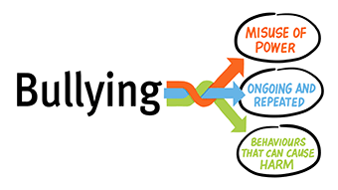
Student Health and Well-Being

Bullying
When staff and students are at Lake Grace DHS they have a right to teach and learn in a safe environment. A school cannot afford to tolerate bullying in any form. We have a moral obligation to act on bullying and educate in order to change the behaviour.

Bullying is defined as any repeated behaviour that is designed to hurt, intimidate or threaten another person. Elements of bullying may appear as wanting to hurt someone and where the bully gets pleasure from hurting the victim or maybe wanting to feel a sense of power over another person (imbalance of power).

Bullying usually fits into three distinct categories:
- Physical bullying – hitting, pushing, kicking or taking or damaging someone else’s property, etc.
- Verbal bullying – name calling, teasing, swearing, threatening, discriminating about race, colour, appearance, religion, etc.
- Social bullying – spreading lies and rumours, exclusion from groups or games, cyber bullying (text messaging, chat forums, social media such as Facebook, etc).
Students, staff and parents all have responsibilities in dealing with bullying. These are outlined in the table below:

Who | What
Students | Report if they are being bullied or see someone else being bullied.
 | Support other students who are being bullied.
 | Not be involved in bullying behaviour.
Staff | Model appropriate behaviour at all times.
 | Deal with all reported and observed incidences of bullying behaviour.
 | Teach students strategies to improve self-esteem and empower themselves.
Parents | Watch for indications that your child may be being bullied. These indications may include: physical injuries like unexplained bruises and scratches, reluctance to go to school, lower academic performance, moodiness, withdrawal, tension and tears after school, talk of hating school, refusal to discuss what's happening at school, bed wetting, altered sleep patterns or having nightmares, changes in eating habits (such as loss of appetite or overeating), major changes in relationships and friendships with others, getting into trouble more often, and acting out.
 | Watch for indications that your child is a bully. These indications may include: aggressive behaviour, cyber bullying on the computer, long phone calls, moodiness, a need for extra money, need to be popular, powerful and in control, rumpled or stained clothing, narcissistic behaviour, low self-esteem, lack of empathy for people or animals, scratches, scrapes and injuries.
 | Report to staff (preferably your child’s class teacher initially) if your child is being bullied, or if you suspect your child is being bullied or is a bully.
 | Instruct your child to report to teachers if they are being bullied.


SDERA
Lake Grace DHS takes a whole school approach to students’ health and well-being and utilises the School Drug Education and Road Aware Program. Through this association with SDERA, we are a member of the “Changing Health, Acting Together” initiative, which includes road safety, resilience and drug education.
In 2017, Lake Grace DHS received the Gold Award in recognition of the work we have done as a school and community to deliver the best possible health outcomes for our students.
As a part of the SDERA Program, we have developed a set of school policies and guidelines on the following:
- Drugs and drug education
- Road safety guidelines
- Guidelines to engaging guest presenters


Chaplain
The Chaplain supports the social, and emotional wellbeing of our students. School chaplains also have a key role in supporting the spiritual wellbeing of their students, regardless of faith or beliefs. School chaplains provide support for a range of day-to-day matters affecting the school community and communicate effectively with a diverse group of people. They can become involved in a wide variety of issues including health, social and values education, and emotional support.

School Nurse
Miss Di Poultney is currently our Community Nurse and visits the school on a regular basis. She conducts sight and hearing screenings in the early years and assists staff in implementing strategies to support students and families. Di can be contacted via the school office.

School Psychologist
Mrs Melanie Smith is currently our School Psychologist who visits our school once per fortnight. The Psychologist is available to assist students with educational, emotional or behavioural difficulties. Referrals are managed by the school leadership team in coordination with class teachers.

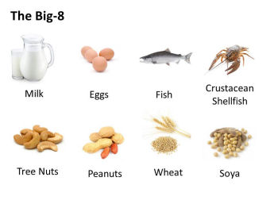
Allergies and Anaphylaxis
As with all schools, we aim to be allergy aware and educate staff and students on good hygiene habits and a ‘no sharing food’ policy. Students with allergies are required to have a medical intervention plan (available from front office).
Important note: All staff are trained in the use of an Epi-Pen each year.

Administration of Medication
Schools require written information to assist and/or supervise students taking any long-term or short-term medication.
Parents should see our staff in the front office to obtain the appropriate paperwork.

Dental Health Service
A mobile dental therapy centre visits the school annually. Parents/guardians will be advised of the date this visit is scheduled to occur via the newsletter and correspondence home. All K-10 students are provided with free examinations and service of a minor nature.

Infectious Diseases
The Health Department has strict guidelines for the management of infectious diseases. Students who contract such a disease may be excluded from school for a period of time. All parents will be notified if such a disease is evident at school.

Disease | Exclusion Time Period
Chicken Pox | Exclude for at least 5 days after vesicles (rash) appear and until vesicles have formed crusts.
Conjunctivitis | Exclude until discharge from eyes has ceased.
Hand, Foot and Mouth | Exclude until all vesicles have formed crusts that are dry.
Impetigo (School Sores) | Exclude for 24 hours after antibiotic treatment has commenced. Lesions on skin surfaces should be covered with a waterproof dressing. Young children unable to comply with good hygiene practices should be excluded until after the sores are dry.
Measles | Exclude for 4 days after the onset of rash, in consultation with public health unit staff.
Mumps | Exclude for 5 days after onset of symptoms. Consult with your public health unit staff.
Pertussis (Whooping Cough) | Exclude for 5 days after an appropriate antibiotic treatment, or for 21 days from the onset of coughing.
Ringworm (Tinea) | Exclude until the person has received anti-fungal treatment for 24 hours.
Rubella (German Measles) | Exclude for 4 days after onset of rash.
COVID-19 (Corona Virus) | Exclude for 14 days.

Head Lice
What are head lice?
Head lice are tiny insect parasites that live on your head and feed on your scalp (the skin covering your head). They reproduce by laying their eggs (nits) on your hair shaft (the part of your hair closest to the scalp). Head lice are not dangerous, do not carry diseases, and are not a sign of poor hygiene (cleanliness).
How do you get head lice?
Head lice are spread by head-to-head contact with another person who has head lice. This kind of contact includes doing group work at school, playing, or hugging.
Head lice can run from one head to another in seconds. Head lice cannot fly, jump or swim, but they can sometimes swing from one hair to another.
Brushes and combs are unlikely to transfer head lice or their eggs, as these are very hard to detach from the hair shaft. Head lice are not spread through bed linen, clothing or head gear (hats and helmets) as they do not leave the scalp unless they are moving to another scalp, or unless they are dead or dying.
Signs and symptoms
- Your scalp may itch as your skin reacts to the saliva of the head lice. This itchiness can take weeks to develop. If you have had head lice before, your skin may become less sensitive and there may be little or no itch.
- You may also be able to see head lice crawling in your hair, although they can be difficult to spot as they move quickly.
- Adult lice are usually dark brown and about 2 to 3 mm long.
- Hatchlings (young lice) are often a lighter brown colour and about 1 to 2 mm long.
- Eggs will be attached to the hair shaft. They can be very tiny and hard to see, especially newly-laid eggs close to the scalp. They are grey-white and about the size of a grain of salt.
Checking for head lice
Unless you can easily see the head lice, the speed at which they can move makes checking dry hair unreliable.
Carefully comb plenty of hair conditioner through dry hair. The conditioner slows the head lice down so they can be trapped in the comb.
Comb hair again in sections using a metal fine-tooth ‘nit comb’ (available from most chemists).
Wipe the waste from the comb on a white paper towel. Look for head lice and eggs using a magnifying glass in strong light, such as sunlight.
Use a magnifying glass in strong light to examine hair close to the scalp, especially behind the ears and at the back of the neck.
Distract children while you check for head lice by offering them a favourite video or game, a book, or a head massage.
What can be mistaken for head lice?
Other objects in the hair can be mistaken for head lice or eggs. These include sand, dandruff, flakes of hair spray, ants, aphids, or other small insects.
If you find head lice
Check to see if anyone else living in your house has head lice – use the hair conditioner method described above.
Choose the treatment method that best suits you and your family and follow the instructions carefully.
Inform your school, child care centre, playgroup, neighbours and relatives so that other children and adults who have been in close contact can be checked.
When the treatment is completed and all head lice and eggs have been removed, continue to check hair weekly for further outbreaks.
Stay home from school
Under the School Education Act 1999, if your child has head lice the Principal may keep him or her away from school until treatment has started.
Your child may return to school when all live head lice have been removed. There is no need to stay away from school if there are only a few remaining eggs, but you must continue treatment over the following 10 days to ensure that all eggs and hatchlings have been removed.
Prevent further outbreaks
- Check hair regularly for head lice and eggs. Early treatment of head lice can prevent it spreading further to close contacts.
- Tie long hair back.
- Hair gel or mousse may help keep stray hair strands from coming in contact with other heads.
- Avoid sharing combs or brushes.
- If you have recently had head lice, leave brushes and combs in hot water for 10 minutes after use to kill any trapped head lice or eggs. Clean them with an old toothbrush to help remove any waste.
- Remind your child to avoid head-to-head contact with other children, for example when working at the computer with others, playing or hugging.
(Acknowledgement - Department of Health WA)

Emergency Procedures
The school has clear procedures for staff to follow should there be an emergency which causes either an evacuation or lock-down.

If such an event occurs, parents will be notified as soon as it is safe to do so.

Throughout the year, staff and students practice these procedures during planned drills.

Lake Grace DHS is on the Bushfire Prone Register. Inclusion on this register means that the school may be required to invoke a pre-emptive closure on a day which a Catastrophic Fire Danger Rating (FDR) has been declared for the Shire of Lake Grace. A Catastrophic FDR means that if a fire starts, it is likely to be uncontrollable, unpredictable and fast-moving.

As soon as we receive advice of this warning we need to contact you, so please have all your contact details up to date - we have an SMS system for emergency notifications.

School Creed
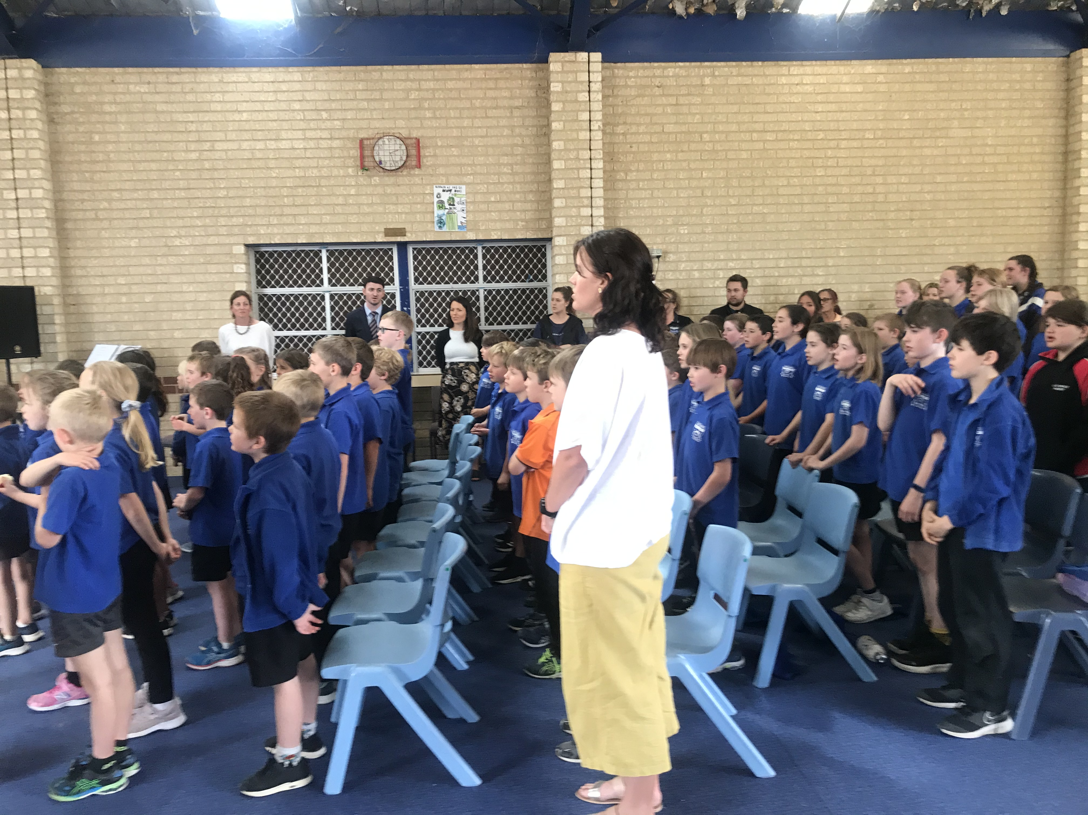
This is our district high school
Country education Lake Grace
We grow together as one
Knowledge we embrace
We strive to succeed always
To the best of our ability
Take the chance presented
In every day opportunity
To share to dare to lift ourselves
To work to understand
Our school our path our entry key
To walk this Southern Land.
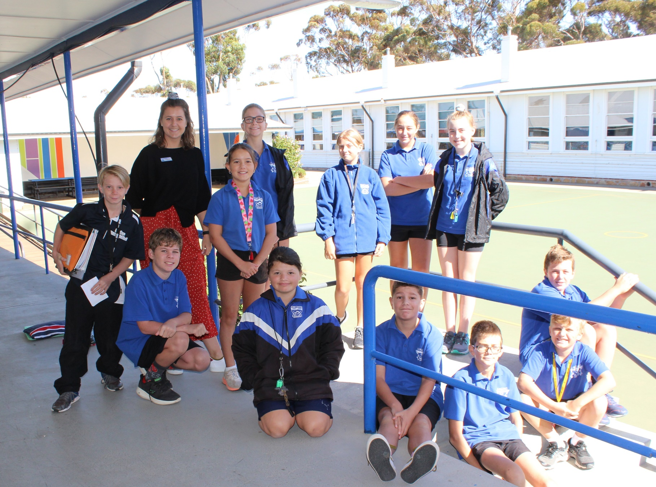
Lake Grace District High School

1 School Place, Lake Grace, W.A, 6353
08 9865 4500 lakegrace.dhs@education.wa.edu.au
www.facebook.com/lakegracedistricthighschool
www.lakegracedhs.wa.edu.au

The Yealering Exception:
Yealering Primary School offers a broad and engaging curriculum to enable our students to develop the knowledge, understanding, skills and abilities they need to be successful learners, develop physically, socially and emotionally and be prepared for the future.

Teaching Learning Process:
The teaching and learning process in underpinned by the Yealering Pedagogical Framework. Staff implement strategies based on the research of John Hattie’s Visible Learning. Our key focus is to develop students to take responsibility for their learning through an Inquiry-based Approach - posing questions to encourage children to work out solutions to problems.

